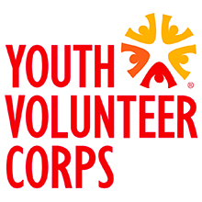
My Civic Life
Youth Advisory Board (YAB) Nomination Form

I, _________________________________________________, am ACCEPTING / DECLINING
(PRINT FULL NAME) (CIRCLE ONE)

my nomination to the Youth Volunteer Corps Youth Advisory Board for the 2017-18 program year. I understand that if I accept my nomination I am agreeing to:

- Participate monthly YAB meetings with no more than two unexcused absences.
- Attend at least six YVC projects during the course of the program year.
- Demonstrate an ongoing desire and ability to contribute to the achievement of the objectives set by the Board.
- Act as an ambassador and advocate for YVC in the community.
- Participate in YVC special events as needed.
- Actively recruit new youth to participate in YVC activities on an ongoing basis.

_______________________________________ ______________
Signature of Youth Volunteer Date

_______________________________________ ______________
Signature of Parent or Guardian Date

YAB Nominees should submit this form to Community Development Works (CDW) at brooke@cdworks.org or fax to 318-448-4473 by September 7, 2017.

For questions about Youth Advisory Board, please contact:
Kyle Shirley
Youth Advisory Board (YAB) Facilitator
Kyleshirley1980@gmail.com
318-426-8229

